* Why solenoid valves are better for med devices <https://www.mddionline.com/solenoid-valves-evolve-medical-devices>
* [DIY Lung](https://simulation.health.ufl.edu/wordpress/files/2020/04/DIY-Test-Lung_OS-Vent.pdf)

Instructions:

15 mm diameter through hole at top of bellows is for connection of a Y-piece or elbow from a ventilator breathing circuit

An alternate simpler design B than design A shown in the hand sketch below is to just wrap and tie a long strip of elastic rubber band around the entire assembly – no need to drill holes on sides of plywood side. You can also use light aluminum plate instead of plywood.

Sliding the rubber band(s) away from the hinge increases stiffness of the lung (DECREASES compliance measured in units of L/cm H2O). Increasing the number or strength of the rubber strips can also be used to alter lung compliance.

If you don’t have a bellows, use the inner tube from a car or truck tire and cut a section and glue/attach] edges to plywood. Bellows attachment to top and bottom plate needs to remain airtight at, and withstand at least, 1 psig (1 psi = 70.3 cm H2O) pressure.

Not shown: tap into the plywood on top of the bellows to measure pressure by connecting a needle pressure gauge with a scale reading cm H2O: ideally the pressure range measured by the gauge is -20 (minus 20) to +80 cm H2O

The range of lung compliance should be 0.1 (normal) to 0.01 (stiff) L/cm H2O at least. Measure compliance by injecting a known volume of air (e.g., 1 L) and measure the increase in pressure. Divide the volume injected in liters by the rise in pressure in cm H2O to obtain the compliance. Experiment to obtain 0.1 and 0.01 and then make marks on the test lung for these 2 settings. You can add orifice plate resistors of different diameters at the 15 mm hole on top of the bellows to simulate different lung resistance

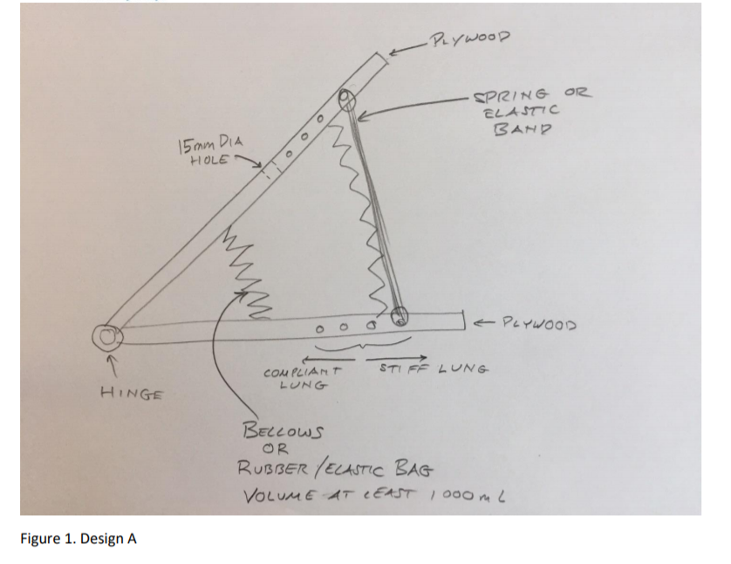

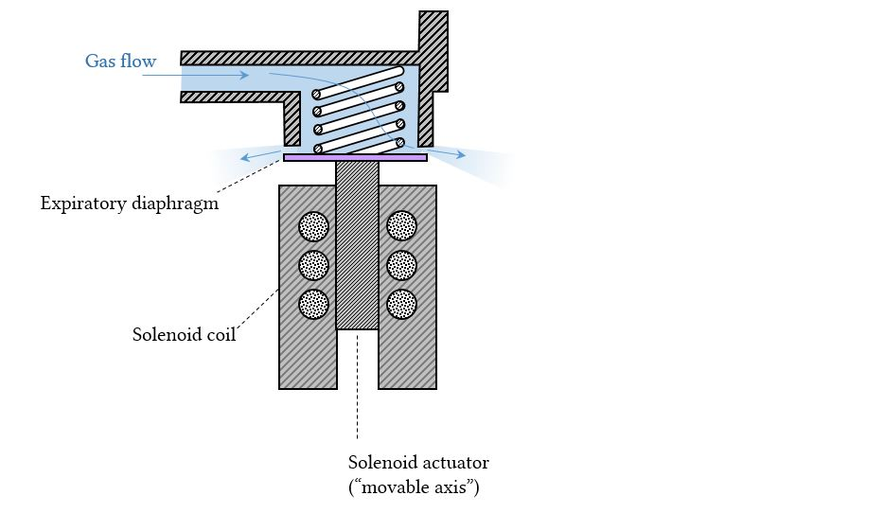

DIY Servo Valve: <https://www.youtube.com/watch?v=S8OJ38VGYcc>

<https://www.thingiverse.com/thing:1659407>